**Experiment no 10**

**Aim:-** Analyzing Data - Implementation of  Association Rule Mining.

**Theory:-**

Association rule mining :-

• Proposed by Agrawal et al in 1993.

• It is an important data mining model studied extensively by the database and data mining community. • It searches for interesting associations or relationships among items in the given dataset.

• With massive amounts of data continuously being collected and stored in databases many industries are becoming interested in mining association rules from the databases.

• Assume all data are categorical.

• No good algorithm for numeric data.

• Initially used for Market Basket Analysis to find how items purchased by customers are related.

**Scenario:-**

**Implementing Association rule mining on the f**

|  |  |  |  |  |  |  |
| --- | --- | --- | --- | --- | --- | --- |
| **Transaction** | | **Items** | | | | |
| T1 | | {pen, pencil, notebook} | | | | |
| T2 | | {pencil, sharpener} | | | | |
| T3 | | {sharpener, pencil, notebook} | | | | |
| T4 | | {pen, notebook} | | | | |
|  | |  | | | | |
| **Transaction** | | **Pen** | **Pencil** | **Notebook** | **Sharpener** | |
| T1 | | 1 | 1 | 1 | 0 | |
| T2 | | 0 | 1 | 0 | 1 | |
| T3 | | 0 | 1 | 1 | 1 | |
| T4 | | 1 | 0 | 1 | 0 | |

Step 1:- Creating a Binary matrix and setting the dimension names for the items of the following data table.

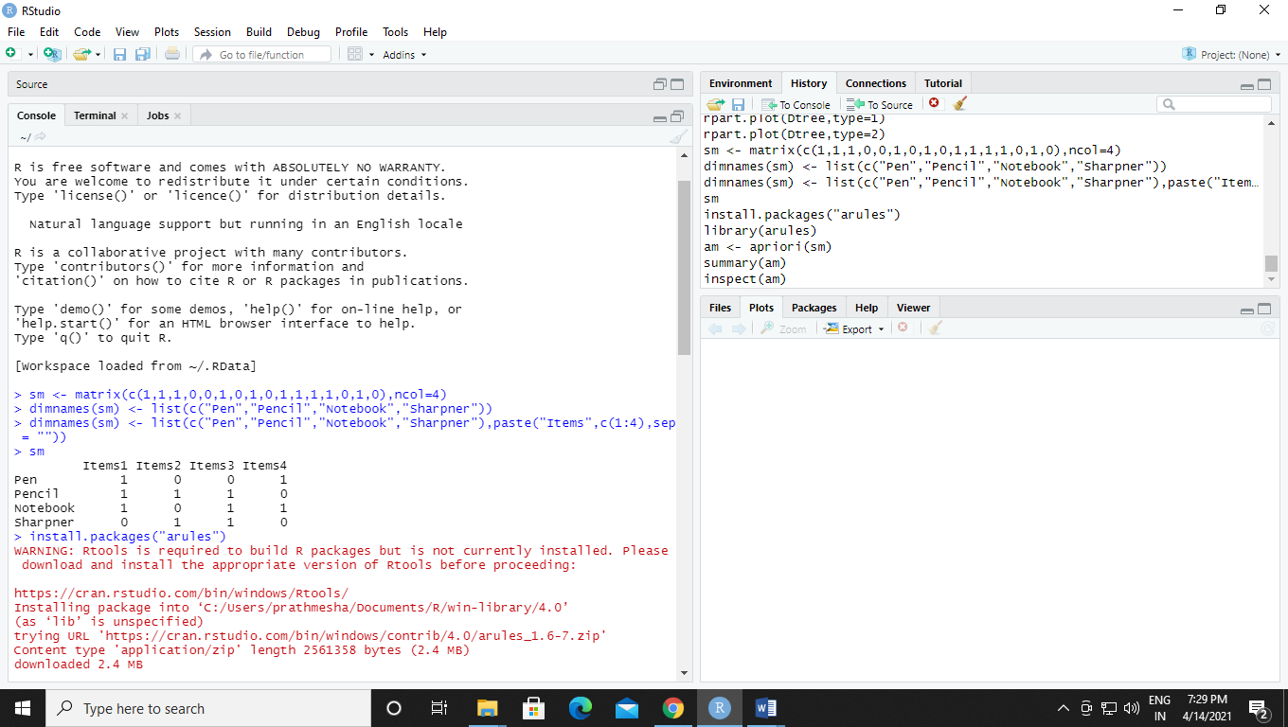

Step 2:- Installing “arules” packages for further implementation.

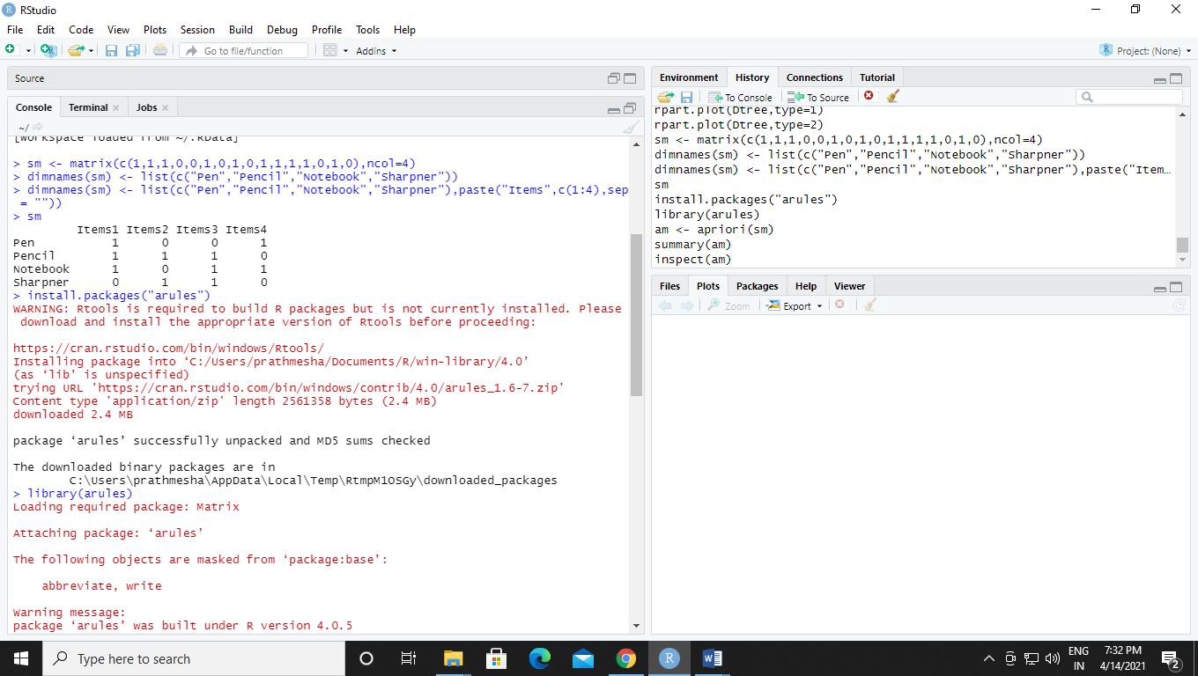

Step 3:- Implementing Association rule mining on the binary matrix and dimensional names for items which is created.

